# 

**think simulation | getting the chemistry right**

OLI versus PHREEQC

Contents

**The challenge of electrolyte simulation 2**

**OLI as an electrolyte model 2**

**PHREEQC as an electrolyte modeling tool 3**

**10 reasons to consider OLI the superior choice 3**

**Models are only as good as the underlying data 3**

**Electrolytes are mathematically complicated and require a strong non-linear solver 4**

**You need an expert to work in PHREEQC 4**

**PHREEQC is difficult to maintain once your expert leaves 4**

**Even with an expert, PHREEQC model is “not good enough” for highly concentrated systems 4**

**Missing an important component can be a dead-end in FREEWARE 4**

**Where do you go to ask important questions about the predictions? 5**

**Surface reactions are not easy to compute accurately 5**

**Reduction / Oxidation (REDOX) is part of the OLI model 5**

**Difficulty in resolving conflicting databases in PHREEQC 5**

**Conclusion 5**

10 reasons why OLI simulation technology is superior to a PHREEQC solution

## The challenge of electrolyte simulation

The mathematical behavior of electrolytes is challenging. Composition changes, hydrate formation, and phase transformation can lead to solution properties that are not easily predicted. A quick look at Figure 1 illustrates this. As the sulfuric acid concentration increases (x-axis), the form of the ammonium sulfate solid changes, and its solubility shifts dramatically. Simulating such behavior using PHREEQ is simply not possible.

Yet, the need to design and simulate processes remain, because it is proven time and again that simulation cuts cost and reduces risk. Therefore, the solution is to use a first-principles tool that is robust enough to model the system of interest. Bad results lead to overdesign, cost-overruns, or more worrisome, HSE risks.

Figure 1 The ternary system of sulfate, ammonia and water

# OLI electrolyte simulator model

OLI’s has a comprehensive electrolyte thermodynamic framework for performing accurate simulation of electrolytes in water and other solvents. This framework covers an unparalleled range of conditions and chemistries. Here is a quick summary of these aspects:

**Concentrations** – Predicting electrolyte solutions from infinite dilution to pure acids or molten salts. This allows clients to model concentrated acids, amine hydrochlorides in refinery overheads, dense-phase CO2, and other non-aqueous solvents (MeOH, EtOH, MEG, etc.). These systems cannot be modeled using the classical strong-electrolyte models such as the molality-based Pitzer theory.

**Mixtures of electrolytes and nonelectrolytes** – Waters and process streams contain many forms of electrolytes and nonelectrolytes, and both types can be inorganic and organic. Salt solutions in methanol or glycols (monoethylene, diethylene, triethylene or polyethylene glycols) are a classical example of organic solvents that dissolve electrolytes. Their solvency towards, polarizability by, and coordination around ions like Fe+3 or NH4+ is computed by the model.

**Temperature and pressure ranges** – The integrated database and model enables predictions to at least 330 °C and up to ~4 kbar. This is essential for modeling high pressure and temperature geochemical systems. The model also predicts sub-zero conditions.

**Phenomena** – Many properties are seamlessly integrated into the database and framework. With each calculation, transport properties (electrical conductivity, viscosity, self-diffusivity, thermal conductivity), surface properties (surface tension, interfacial tension), redox equilibria, and adsorption phenomena (surface complexation, ion exchange, and molecular adsorption) can be computed.

# PHREEQC as an electrolyte simulator modeling tool

**PHREEQC** (PH REdox EQuilibrium in C/C++ language) is popular, free software for electrolyte modeling published by the USGS. From the USGS website, “PHREEQC has several types of aqueous models: two ion-association aqueous models (the Lawrence Livermore National Laboratory model and WATEQ4F), a Pitzer specific-ion-interaction aqueous model, and the SIT (Specific ion Interaction Theory) aqueous model. Using any of these aqueous models, PHREEQC has capabilities for

(1) speciation and saturation-index calculations;   
(2) batch-reaction and one-dimensional (1D) transport calculations with reversible and irreversible reactions, which include aqueous, mineral, gas, solid-solution, surface-complexation, and ion-exchange equilibria, and specified mole transfers of reactants, kinetically controlled reactions, mixing of solutions, and pressure and temperature changes; and   
(3) inverse modeling, which finds sets of mineral and gas mole transfers that account for differences in composition between waters within specified compositional uncertainty limits” 1

There are several databases for PHREEQC by other organizations.

At first glance PHREEQC is an attractive solution, and it is tempting for a savvy organization to think that they can reap the benefits of electrolyte modeling solution at no cost. However, it is not cost free:

# Top ten (10) reasons to consider OLI the superior choice for electrolyte modeling

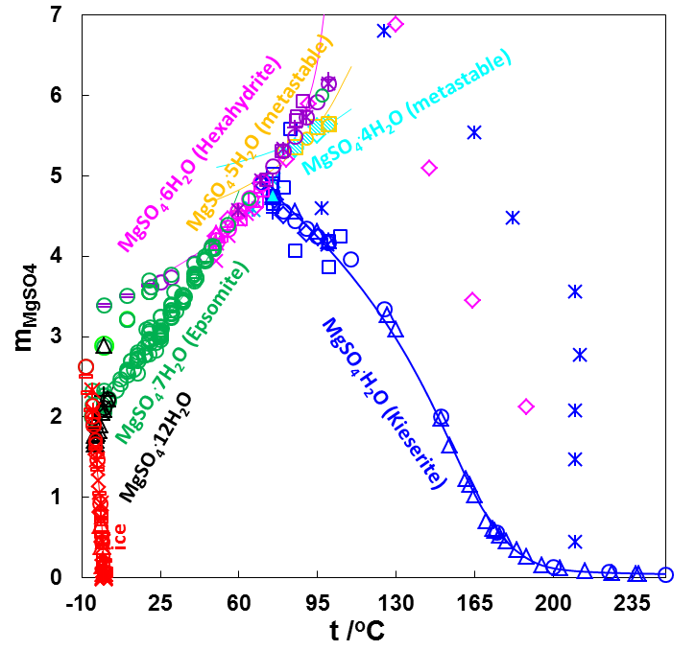Upon closer analysis, PHREEQC is a suboptimal long-term strategy for industrial ‘real world’ solution, for several reasons.

## 1. A model is only as good as the underlying data, and that takes time to create:

A model that predicts accurately your system of interest takes time to develop. We know this because developing OLI’s framework and databases have consumed nearly one-half million hours. This is where you can expect to spend your time:

* Searching for or measuring experimental data;
* Developing a knowledge that enables you to assess the data quality;
* Developing skills needed to create the regression files properly – regression files that represent the experimental data being tested;

Figure 2 - Solubility of solids in MgSO4 solutions

* Developing technical knowledge to know which electrostatic or thermodynamic parameters should adjusted
* Developing the thermodynamic knowledge to improve or extend the chemical mechanisms being studied
* Monitoring the predictions to ensure that the model remains predictive, when used beyond the range over which is was regressed (e.g., higher temperature, new components, different ion ratios).

OLI has already made the investments in time, training, and education to develop these models correctly. That is why the software works “out-of-the box” for a wide range of systems, and for systems that are incomplete in MSE, e.g., transition metals for those at higher atomic numbers, OLI offers priority additions in return for co-funding part of the development.

The OLI databases are built on tens of thousands of peer reviewed papers and hundreds of thousands experimental data points. This is the investment needed to make a truly comprehensive database and thermodynamic framework. With OLI you are assured of getting the finest quality underlying data for the development of parameters.

## 2. Electrolytes are mathematically complicated and requires a strong non-linear solver.

The (NH4)2SO4-H2SO4-H2O system in Figure 1 displays a high degree of non-linearity. It is easy to see the need for sophisticated heuristics to address these mathematical solutions. Achieving convergence when pressing the calculate button is not a guarantee. It takes talented mathematicians to produce solver routines that can predict **true** equilibrium in multi-phase, multi-component systems.

## 3. You need an expert to work in PHREEQC

Skilled thermodynamicists are needed to evaluate the output of any software program. If you are not a thermodynamicists, then the risk of arriving on an inaccurate result is elevated. OLI maintains a team of skilled thermodynamic experts who ensures the validity and integrity of the predictions. This is an assurance that you cannot obtain from freeware.

## 4. PHREEQC is difficult to maintain once your expert leaves

A freeware interface has no supporting programming. If something does not work, it may never be fixed, or if a feature or calculation is needed, it is the burden of the user to create it. OLI is commercial software, and it has several releases each year, with improvements to the UI, the database, and the thermodynamic framework. A commercial software has the ability to expand to meet the needs of the industry. That is what OLI does.

## 5. Even with an expert, PHREEQC models were not robust enough for high concentration systems

An OLI client working at Shell Oil Company with extensive PHREEQC experience was forced to rewrite a PHREEQC models to handle high concentrations. This work was presented at an OLI Simulation conference in 2016. By special arrangement with OLI, he was permitted to use the OLI simulation parameters and wrote an “OLI MSE-like” set of equations to achieve the accuracy that OLI provides “out of the box.” 2 The cost in time to do this was quite high, in fact many times higher than the cost of the license.

## 6. Missing an important input component can be a dead-end in Freeware

The risk with PHREEQC is to miss a necessary component in the existing database. Under such circumstances, the user has no choice but to build a private database containing the necessary chemical reactions and equilibrium constants. What if there are no constants, what if the reaction is at elevated temperature or salinity? It may be easy to create a chemical reaction and add a fixed equilibrium constant. Such a database will be limited to a single temperature and composition. If this new component forms a complex with other species, if this component ionizes, and if the solution has any salinity, then such a database will become useless quickly.

With OLI the opposite is often true. One client who is experienced in both PHREEQC and OLI observed that with OLI you start with everything, and then you simplify, while with PHREEQC you start with a limited database that you have to flesh out. The issue with OLI is that you will possibly spend time considering species that will not form, while for PHREEQC if you miss a component in your database you might actually be completely wrong. Complexing agents are typical examples of things that can go wrong in PHREEQC.

## 7. Where do you go to ask important questions about the predictions?

When you have questions about your freeware results, who do you contact? Gypsum is precipitating instead of anhydrite. Why is this? If this is not your area of expertise, then considerable time is spent in the library or on the internet looking for answers. If such questions arise when using OLI software, there is a team of experts to answer your question, and the answers can go as deep as the fundamental thermodynamics or the original experimental data. Developing such expertise does not happen overnight, it has taken 48 years of company development and team learning that brings us to this level. We are a team of thermodynamicists, dedicated to electrolyte science, and this expertise come as part of an OLI services package that anyone on your team may access.

## 8. Surface reactions are not easy to compute accurately

Surface reactions at the solid-liquid interface can be modeled in a generic way within PHREEQC. However, the desire to close the energy balance and mass balance (crystal vs. surface groups) needs to be suspended. Also, to work at conditions and compositions that extend beyond your database causes inaccuracies. For example, the extent of ionization of a hydrous ferric oxide surface is not constant with temperature or salinity. Such limitations must be built into the model. An investment in time and education is required to expand the range of surface reactions to fit your particular situation.

OLI reactions include surface complexation and ion exchange, and the database that predicts these reactions is professionally maintained; the capability to close the energy and mass balance comes as a feature of the software.

**9. Reduction / oxidation (REDOX) is part of the OLI model**

REDOX reactions are not a simple on-off switch. Elements can have many oxidation states and some states are transient or kinetically limited. It is essential that a user selectively chooses which oxidation state to allow, and it is highly desirable not to be forced to rewrite the chemical reactions. This can cost hours of time. Selectively eliminating oxidation states takes seconds to complete and rebuilding REDOX reactions is done automatically.

**10. Difficulty in resolving conflicting databases in PHREEQC**

According to Dethlefsen et. al, the databases distributed with PHREEQC yield contradictory results. Which results do you trust? There is no support structure to help with this. OLI has spent the past four decades managing and eliminating such contradictions and their team of thermodynamicists are available to address such problems as they arise. This is what makes professionally maintained software professional.

# Conclusions

Both PHREEQC and OLI software are proven methods to model electrolyte systems. The years of research and refinement in each of these software packages is significant. Both require skilled thermodynamicists and mathematicians to perform properly. With PHREEQC, that person must be the user. With OLI software, it is the team of personnel. OLI provides this service and builds it into a higher-level access for easier use. OLI has leveraged the leases from hundreds of clients to develop more robust, more accurate, and more comprehensive software. Thus, when you use OLI software, you are benefiting from the work we completed for thousands of clients that have used it before you.

# References

1. Parkhurst, D.L., and Appelo, C.A.J., 2013, *Description of input and examples for PHREEQC version 3—A computer program for speciation, batch-reaction, one-dimensional transport, and inverse geochemical calculations*: U.S. Geological Survey Techniques and Methods, book 6, chap. A43, 497 p., available only at <https://pubs.usgs.gov/tm/06/a43/>

2. Tambach, T., *Bringing OLI MSE into PHREEQC for reservoir simulations – application to subsurface challenge*, OLI Simulation Conference, 2016.

3. Dethlefsen, F., C. Haase, M. Ebert, and A. Dahmke, *Uncertainties of geochemical modeling during CO2 sequestration applying batch equilibrium calculations*. Environmental Earth Sciences, 2011. 65(4): p. 1105-1117.

**For more Information**

**Authors: Pat McKenzie, Anthony J. Gerbino, OLI Systems   
Contributions by: Marc LaLiberte, Veolia Water Technologies , and Andre Anderko, OLI Systems**

[www.olisystems.com](http://www.olisystems.com)

# 